FINAL YEAR PROJECT
CryptoSence



GOVT. GRADUATE COLLEGE, CIVIL LINES,
SHEIKHUPURA

Supervisor: Sir Muhammad Kamran

Submitted By:
Syed Mohsin Abbas | 2022-KS-178 | 2022-089330
Hamza Nadeem | 2022-KS-171 | 2022-089305

Session: 2022-2026

Project ID: 22-KS-BSIT-16
Bachelor of Science in Information Technology
FINAL YEAR PROJECT REPORT
CryptoSence

A project Presented to
Faculty of Computing and Information Technology (FCIT)
University of the Punjab
Lahore

In partial fulfillment of the requirement for the degree of
Bachelor of Science in Information Technology
Session (2022-2026)

Submitted By:
Syed Mohsin Abbas | 2022-KS-178 | 2022-089330
Hamza Nadeem | 2022-KS-171 | 2022-089305

DECLARATION
The work reported in this project was carried out by us under the supervision of our project supervisor, Sir Muhammad Kamran, at Government Graduate College, Civil Lines, Sheikhupura.
We affirm that this project, along with its contents, is the result of our independent research efforts. No portion of this work has been directly copied from any previously written or published material, except for referenced sources, standard mathematical or scientific models, equations, formulas, protocols, etc. Furthermore, we confirm that this work has not been presented for the attainment of any other academic degree or diploma.
The university may take appropriate action if the provided information is found to be inaccurate at any stage.

Student Name | Registration No. | Signature
Syed Mohsin Abbas | 2022-KS-178 | 2022-089330
Hamza Nadeem | 2022-KS-171 | 2022-089305

STATEMENT OF SUBMISSION
This is to certify that the following students have worked on their final year project, titled CryptoSence, at Government Graduate College, Civil Lines, Sheikhupura, as part of the partial requirements for the degree of Bachelor of Sciences in Information Technology.

Serial No. | Registration No. | Roll No. | Student Name
1 | 2022-KS-178 | 089330 | Syed Mohsin Abbas
2 | 2022-KS-171 | 089305 | Hamza Nadeem

Head of Department  Muhammad Ali Waqas  Associate Professor of Computer Science  Govt. Graduate College,  Civil Lines, Sheikhupura | Supervisor  Muhammad Kamran  Lecturer in Computer Science  Govt. Graduate College,  Civil Lines, Sheikhupura

Project Coordinator
Hasan Raza
Lecturer in Computer Science
Govt. Graduate College,
Civil Lines, Sheikhupura

PROOFREADING CERTIFICATE
This is to certify that Syed Mohsin Abbas (Roll#089330) and Hamza Nadeem (Roll#089305) have prepared documentation for their final year project (FYP) titled CryptoSence at the Department of Computer Science, Government Graduate College, Civil Lines, Sheikhupura, in partial fulfillment of the requirements for the degree of Bachelor of Sciences in Information Technology.

Project Coordinator
Hasan Raza
Lecturer in Computer Science
Govt. Graduate College,
Civil Lines, Sheikhupura

Acknowledgement
We would like to express our sincere thanks to Sir Muhammad Kamran, Lecturer at Government Graduate College, Civil Lines, Sheikhupura, for his valuable guidance, encouragement and support during the preparation of our project documentation.
We are also thankful to our friends and families for their quiet support and motivation, which helped us stay focused throughout this phase of our work.

Date: January 27, 2026

PROJECT INFORMATION

Project Title | CryptoSence
Objective | To build a Crypto Tracker with AI Chatbot
Undertaken by | Syed Mohsin Abbas and Hamza Nadeem
Supervised by | Sir Muhammad Kamran
Starting Date | 02/10/25
Completion Date | 30/06/26 (Expected)
Tools Used | Visual Studio Code
Technologies | React.JS, Node.JS, Express.JS, MongoDB, Coingecko API, Gemini API

PREFACE
This is a final year project (FYP) report written by students of Bachelor of Science in Information Technology at the University of the Punjab. We are Syed Mohsin Abbas and Hamza Nadeem, both of us are studying in BSIT (Hons) at Government Graduate College, Civil Lines, Sheikhupura.
To enable you to understand the idea of our project and the implementation process in detail and systematically, this report is divided into topics; each topic with a specific focus. We hope this approach allows you to read and understand our project report easily. Lastly, if you have any comments, you are welcome to contact us at:

Member 1: | Syed Mohsin Abbas | syedmohsinabbas7212@gmail.com
Member 2: | Hamza Nadeem | hamzanadeem4956@gmail.com

Abstract
This project is a web based cryptocurrency dashboard and also merged with an AI Chabot. This system provides real time price and market update for traders. Using APIs such as Coingecko and Gemini for user can see live market data of multiple cryptocurrencies and ask questions about trends and prediction from chatbot. This system helpful for traders to its analysis and also get knowledge about crypto trading.

CryptoSence

Executive Summary
CryptoSence is a web based cryptocurrency dashboard enhanced with a secure login system and a Cryptobot. It allows users to view real time crypto prices, analyze charts, and interact with a chatbot for prediction and explanation. The system combined with Coingecko API for live market data and Gemini API for Cryptobot responses. A Node.js and Express are backend manages authentication, while MongoDB stores user data securely.

FYDP Overview
FYDP Title: CryptoSence
Sr. No | Roll No | Name | Signature
1 | 089330 | Syed Mohsin Abbas
2 | 089305 | Hamza Nadeem
Table 1 Project Proposal Summary
FYDP Goals
To develop an interactive crypto dashboard that combine real time price tracker with a Cryptobot for market understanding and analysis.
FYDP Objectives
Provide a real time analysis of cryptocurrencies.
Provide a Cryptobot for trading support.
Display charts, trends, and top cryptocurrencies.
Enable a user friendly interface for trading analysis.
FYDP Success Criteria
This project will be considered as successful if ,
Trader is happy with the real time price update
User earns money by the use of our AI based website
Assumptions
Users have internet access
Basic trading knowledge.
Risks & Obstacles
Most of the time API demand change in code
If API key is paid then website cost is expensive
The app may not work properly if the crypto data API becomes slow
Organization Address: Govt. Graduate College, Civil Lines, Shiekhupura
Target End Users: Retail crypto traders, students, educators, crypto communities
Suggested Project Supervisor: Muhammad Kamran
Approved by: Muhammad Kamran
Date: October 24, 2025
Table of Contents
Abstract 9
CryptoSence 10
Executive Summary 10
FYDP Overview 11
Chapter No 1 17
Project Proposal 17
1.1. Introduction 18
1.2. Background 18
1.3. Problem Statement 18
1.4. Stakeholders & Interests 18
1.5. Objectives 19
1.6. Scope 19
1.7. Assumptions 19
1.8. Risks 19
1.9. Success Criteria 20
1.10. Tools, Libraries & Technologies 20
1.11. Work Division 21
1.12. Conclusion 21
Chapter No 2 22
Literature Review 22
2.1 Literature Survey 23
2.2 Related Work 23
2.3 Gap Analysis 23
2.4 Summary 23
Chapter No 3 24
Software Requirements Specification 24
3.1 Requirements Analysis 25
3.2 User Classes & Characteristics 25
3.3 Requirements Identifying Techniques 25
3.4 Functional Requirements 25
Functional Requirement 1 26
Functional Requirement 2 26
Functional Requirement 3 27
Functional Requirement 4 27
Functional Requirement 5 28
Functional Requirement 6 28
Functional Requirement 7 29
Functional Requirement 8 29
3.5 Non-Functional Requirements 30
1. Reliability 30
2. Usability 30
3. Performance 30
4. Security 30
3.6 External Interface Requirements 31
1. User Interface Requirements 31
2. Software Interfaces 31
3. Hardware Interfaces 31
4. Communication Interfaces 31
3.7 Use Case Analysis 32
Use Case #1 – Registration 32
Use Case #2 – Login 32
Use Case #3 – Forget password 33
Use Case #4 – Google Sign in/up 34
Use Case #5 – Dashboard 35
Use Case #6 – Cryptobot 36
Use Case #7 – Learning Hub 36
Use Case #8 – Logout 37
Use Case Diagram 38
3.8 Storyboard 39
3.9 Summary 39
Chapter No 4 40
Software Design Specification 40
4.1 System Design 41
Product Perspective: 41
Dependencies: 41
Design Constraints: 41
4.2 Design Considerations 42
Assumptions 42
Dependencies 42
Limitations 42
Risks 42
4.3 Requirements Traceability Matrix 43
4.4 Design Models 44
1. Design Class Diagram 44
2. Sequence Diagram 45
3. State Diagram 47
4.5 Architectural Design 49
1. Architectural Diagram 49
2. UML Component Diagram 50
4.6 Data Design 50
1. Database Collections Structure: 51
2. Data Dictionary 51
4.7 User Interface Design 52
1. Screen Images 54
2. Screen objects and action 58
4.8 Design Decisions 58
4.9 Summary 59
References 60
References 61
1. World Wide Web 61

List of Tables
Table 1 Project Proposal Summary 11
Table 2 Stakeholders & Interest table 18
Table 3 Success Criteria table 20
Table 4 Tools, Libraries & Technologies table 20
Table 5 Work Division table 21
Table 6 Gap Analysis table 23
Table 7 User Classes & Characteristics table 25
Table 8 Functional Requirement 1 26
Table 9 Functional Requirement 2 26
Table 10 Functional Requirement 3 27
Table 11 Functional Requirement 4 27
Table 12 Functional Requirement 5 28
Table 13 Functional Requirement 6 28
Table 14 Functional Requirement 7 29
Table 15 Functional Requirement 8 29
Table 16 Use Case 1 32
Table 17 Use Case 2 32
Table 18 Use Case 3 33
Table 19 Use Case 4 34
Table 20 Use Case 5 35
Table 21 Use Case 6 36
Table 22 Use Case 7 36
Table 23 Use Case 8 37
Table 24 Requirement Traceability Matrix table 43
Table 25 Data Collection table 51

Table of Figures
Figure 1 Use Case Diagram 38
Figure 2 storyboard picture 39
Figure 3 Design Class Diagram 44
Figure 4 User Registration Sequence Diagram 45
Figure 5 Home page Sequence Diagram 46
Figure 6 User Registration State Diagram 47
Figure 7 Home Page State Diagram 48
Figure 8 Architectural Diagram 49
Figure 9 UML Component Diagram 50
Figure 11 Home Page design 54
Figure 12 Login Page Design 55
Figure 13 Dashboard Page Design 56
Figure 14 Cryptobot Page Design 57

Chapter No 1

Project Proposal

Introduction
This chapter explains what the CryptoSence project is about and why it was developed. It gives a basic idea of the system and how it helps users understand cryptocurrency market data easily. It also explains the main purpose and direction of the project.

Background
The cryptocurrency market is highly volatile. The trader uses multiple tools to monitor coin price and market trends. However current crypto tracking websites are not user friendly. They also need technical knowledge for the analysis of charts. People use multiple websites for the analysis of crypto coins. That’s why we are build a system which help the trader to analyze crypto live coins and seems other market updates. This system will help the trader to use AI based market analysis.

Problem Statement
It is hard for user to find cryptocoins data and fast market movement. Currently available dashboards provide simple data without personal assistance. Traders need advance crypto tracker which shows live price and give some analysis about it.

Stakeholders & Interests
Table 2 Stakeholders & Interest table
Stakeholder | Description | Interest
Crypto Traders | They want quick updates and AI help to make better trading decisions. | Real time analysis and AI support
Financial  Analysts | They want short and clear reports to study market trends easily. | Summarized crypto data
Students | They want to learn about crypto trading and how to study market data. | Learning platform and financial analysis

Objectives
- Provide a real time analysis of cryptocurrencies.
- Provide a Cryptobot for trading support.
- Display charts, trends, and top cryptocurrencies.
- Enable a user friendly interface for trading analysis.

Scope
- In-scope
- The system will focus on cryptocurrency price tracking.
- It will provide market updates in real time.
- It will include AI support for basic analysis.
- The project will be web based.
- Out-of-scope
- The system will not support live trading.
- It will not handle or store user funds.

Assumptions
This project is made with some basic assumption. It is assumed that users have internet access and know how to use a website. Users should have basic knowledge of cryptocurrency. It is also assumed that APIs like Coingecko and Gemini will continue to work properly.

Risks
There are some risks in this project. The system depends on external APIs and if these APIs stop working or become slow, the system may not work properly. Free APIs also have limits and using paid APIs may increase project cost.

Success Criteria
Table 3 Success Criteria table
User Registration and Login
Real time Crypto Data
Dashboard Performance
Cryptobot Response
Data Accuracy
Security
User Interface
Cross Platform Compatibility
Error Handling
System Stability
Third-Party Integration (Coingecko, Gemini)
Scalability

Tools, Libraries & Technologies
Table 4 Tools, Libraries & Technologies table
Tools,  Libraries, And  Technologies | Tools | Version | Rationale
 | VS Code | Latest | Use to main code editor, styling
 | Libraries | Version | Rationale
 | React.JS, Node.JS, Express.JS, Chart.JS | Latest | UI design, backend, Charting
 | Technology | Version | Rationale
 | Coingecko API, Gemini API, MongoDB | Latest | Display coins information, Cryptobot, Database management

Work Division
Table 5 Work Division table
Sr. No | Roll No | Name | Role Assignment & Work Division
1. | 089330 | Syed Mohsin Abbas | Frontend & Backend
2. | 089305 | Hamza Nadeem | Frontend & Backend

Conclusion
This chapter explained the CryptoSence project, its goals, assumptions, risks, and expected results. It also showed how the system can help users understand cryptocurrency trading in a simple way.

Chapter No 2

Literature Review

Literature Survey
This section talks about existing cryptocurrency websites and tools. It explains how current systems provide price data and charts, and what features they are missing. This helps understand why a better system like CryptoSence is needed.

Related Work
- Coinmarketcap & Binance dashboards provide real time data but lack AI interactivity.
- ChatGPT and Google Gemini can talk with users and help explain financial data in an easy way.
- TradingView offers technical analysis but no personal chat experience.

Gap Analysis
Table 6 Gap Analysis table
Existing System | Limitations | Over Solution
Current crypto dashboards mainly show charts and prices. | They only focus on visualization and do not explain the data. | Our system will provide real time crypto data with Cryptobot support.
Users can see crypto information but cannot interact or ask questions. | No option to get coin details or understand market trends easily. | The Cryptobot will answer user questions and explain crypto information.
Existing platforms are not designed for learning or easy  understanding | Users cannot learn about crypto terms or analysis through these dashboards. | The project will combine data display with AI based learning and explanations.

Summary
This chapter reviewed existing cryptocurrency platforms and tools. It showed that most systems provide data but do not explain it clearly. To solve this, CryptoSence combines real time data with an AI chatbot to help users understand the market more easily.

Chapter No 3

Software Requirements Specification

Requirements Analysis
The requirement analysis is a part of SRS which define what the CryptoSence do functionally and non-functionally. The main point is to create an intelligent crypto analysis platform that is secure, scalable, and easy to use.

User Classes & Characteristics
The CryptoSence have only one user class, End user.
Table 7 User Classes & Characteristics table
User Class | User Characteristics
End user | The End user could be crypto trader, financial analyst and students which take crypto real time price tracker and a Cryptobot for trading support

Requirements Identifying Techniques
The identifying requirements need to meeting with stakeholder by following step:
- Interview:
We conducted interviews with stakeholders which involve crypto trader, crypto teachers, financial analyst and Whatsapp crypto user groups to record user requirements.
- Ethnography and Observation:
We observed that users need a system that provides real time cryptocurrency price tracking and AI-powered support for analyzing market trends and making predictions. This system would help traders perform market analysis and make informed trading decisions without the need to visit multiple websites.
- Use Case Analysis:
Defined interactions between users and system modules (Home page, Login, Dashboard, Cryptobot, Learning Hub).

Functional Requirements
This section describes the functional requirements of the system expressed in the natural language style. This section is typically organized by feature as a system feature name and specific functional requirements associated with this feature. So, for each module and it’s feature the functional requirements are itemized below:

Functional Requirement 1
Table 8 Functional Requirement 1
Identifier | FR-1
Title | User Registration
Requirement | The user shall be able to register by entering username, email and password then account create.
Source | Business Requirement
Inputs | Username, email address, and password provided by the user.
Destination | The entered user account information is stored securely in the MongoDB database.
Outputs | The system displays a successful account creation message and send to the home page.
Rationale | Provide access control and data security.
Business Rule | Password must be at least 8 characters and other also include number
Dependencies | FR-2
Priority | High

Functional Requirement 2
Table 9 Functional Requirement 2
Identifier | FR-2
Title | User Login
Requirement | The user should be login by entering email and password then view the dashboard.
Source | Business Requirement
Inputs | Registered email address and password entered by the user.
Destination | The system verifies the credentials and creates a secure user session.
Outputs | The user is successfully authenticated and move to the home page
Rationale | Provides access control and data security.
Business Rule | User must be registered before sign in.
Dependencies | FR-1
Priority | High

Functional Requirement 3
Table 10 Functional Requirement 3
Identifier | FR-3
Title | Forget password
Requirement | The user shall be able to reset their password by email A reset link will be sent to the provided email and allowing the user to create a new password
Source | Business Requirement and interview
Inputs | Registered email address entered by the user.
Destination | The updated password is securely stored in the MongoDB database.
Outputs | A password reset confirmation message is displayed after the password is reset.
Rationale | The users regain access if they forget their password
Business Rule | The email must be registered and verified before sending the reset link
Dependencies | FR-2
Priority | High

Functional Requirement 4
Table 11 Functional Requirement 4
Identifier | FR-4
Title | Google Sign-In/Up
Requirement | The user should be sign in/up by google account
Source | Business Requirement and interview
Inputs | Google account credentials provided by the user.
Destination | The user profile is created and stored securely in the database.
Outputs | The user is successfully authenticated and move to the home
Rationale | Very simple process
Business Rule | Must have an google account of user
Dependencies | None
Priority | High

Functional Requirement 5
Table 12 Functional Requirement 5
Identifier | FR-5
Title | Dashboard
Requirement | The user can access real time price, percentage coin and market data, search bar for searching any currencies and also view crypto currencies charts and other update which you went to know.
Source | Business Requirement and interview
Inputs | Coin name enter by the user and internet connection.
Destination | Crypto data is shown on the dashboard screen.
Outputs | Live price, percentage change, and chart of the selected cryptocurrency.
Rationale | Main functionality for traders
Business Rule | Must have good internet access
Dependencies | FR-1, FR-2, FR-3
Priority | High

Functional Requirement 6
Table 13 Functional Requirement 6
Identifier | FR-6
Title | Cryptobot
Requirement | The user can know about any cryptocurrencies prediction, trends and also few line of explanation about coins
Source | Interview, Observation
Inputs | User questions related to cryptocurrency for prediction
Destination | Cryptobot responses are generated using the Gemini API and shown on the screen.
Outputs | Simple explanations and trend information about cryptocurrencies.
Rationale | Improve the analysis of the user and market analysis
Business Rule | Need best internet support and knowledge about crypto
Dependencies | FR-1, FR-2, FR-3
Priority | High

Functional Requirement 7
Table 14 Functional Requirement 7
Identifier | FR-7
Title | Learning Hub
Requirement | The user can also access the best education platform, books and YouTube channel links which will be arranged in sequence of learning
Source | Interview, Observation
Inputs | User selection of learning content.
Destination | Learning content is displayed on the Learning Hub page.
Outputs | Educational materials, book links, and YouTube video links are shown to the user.
Rationale | Improve the skill of crypto trader and learners
Business Rule | If a student wants to learn crypto they should follow the steps in the order shown
Dependencies | FR-1, FR-3
Priority | Medium

Functional Requirement 8
Table 15 Functional Requirement 8
Identifier | FR-8
Title | Logout
Requirement | The user went to logout from dashboard securely
Source | Observation
Inputs | Logout request from the user.
Destination | The user session is ended and access is closed.
Outputs | The user is logged out successfully and move to the login page.
Rationale | Ensure user data security
Business Rule | User must be Login in the website
Dependencies | FR-2, FR-3
Priority | Medium

Non-Functional Requirements
These are constraints on the services or functions offered by the system. They include timing constraints, constraints on the development process, and constraints imposed by standards. Non-functional requirements often apply to the system as a whole rather than individual system features or services. Following are non-functional requirements:

Reliability
- The system should be up and running 99% of the time.
- It should retry automatically if API requests fail.

Usability
- The dashboard must be easy to use and reachable in 4 clicks or less.
- The Cryptobot should use simple English.
- The design should work well on both computers and mobiles.

Performance
- Dashboard data should load within 5 seconds.
- Cryptobot replies should come within 10 seconds.
- Database tasks should take less than 200 milliseconds.

Security
- Passwords are stored safely using bcrypt hashing.
- Login uses JWT (JSON Web Tokens) for authentication.
- The site uses HTTPS for secure data transfer.
- API keys are hidden in environment files.

External Interface Requirements
This section describes how our CryptoSence system will interact with users. It covers the user interface design, software connections, and communication methods.

User Interface Requirements
- Pages:
  - Home Page with Navbar and quick access buttons
  - Login / Register Page
  - Dashboard (price tracker, chart section, search bar)
  - Cryptobot Page
  - Learning Hub Page
- Design Elements:
  - Navbar with links to Dashboard, Cryptobot, Learning Hub and Logout
  - Card-based layout for coin data
  - Chat window for conversation with Cryptobot

Software Interfaces
- Frontend: React.js, HTML5, CSS3
- Backend: Node.js + Express.js
- Database: MongoDB
- APIs:
  - Coingecko (Real time market data)
  - Gemini API (Cryptobot)

Hardware Interfaces
- Runs on standard devices (laptop, mobile).
- Requires a good internet connection.

Communication Interfaces
- HTTPS protocol for secure communication.
- RESTful API endpoints for data and authentication.

Use Case Analysis

Use Case #1 – Registration
Table 16 Use Case 1
Use case ID | UC-1
Requirement traceability | Registration (FR-1)
Purpose | Purpose is to authenticate a user so they can access their dashboard
Priority | High
Preconditions | User must use accurate email and password for registration
Postconditions | When all requirement fulfil the user register and go to login page
Actor | End user
Extends | Google sign in/up
Main success scenario | - User open the website.  - Click the register button for registration.  - User enter the username, email, password and submit.  - The account creates according to giving data.  - And user login now.
Alternate Flow | - If Email already used it show error  - If info is missing ask user to fill all fields
Exceptions | If username, email and password are not fulfil the show error incomplete info and if not write password according to requirement so also show error password must be at least 8 characters
Includes | None

Use Case #2 – Login
Table 17 Use Case 2
Use case ID | UC-2
Requirement traceability | Login (FR-2)
Purpose | Purpose is to authenticate a user so they can access their dashboard
Priority | High
Preconditions | User must use accurate email and password for registration
Postconditions | When all requirement fulfil the user register and login
Actor | End user
Extends | Google sign in
Main success scenario | - User open the website.  - Click the register button for registration.  - User enter the username, email, password and submit.  - The account creates according to giving data.  - And user login now.
Alternate Flow | If wrong email or password enter it show error
Exceptions | Wrong email or password show invalid login detail
Includes | Forget password

Use Case #3 – Forget password
Table 18 Use Case 3
Use case ID | UC-3
Requirement traceability | Forget password(FR-3)
Purpose | The purpose is that if user forget his password then change it
Priority | Medium
Preconditions | The email must be verify
Postconditions | The system updates the user password and sends confirmation of successful reset
Actor | End user
Extends | None
Main success scenario | - User opens the login page  - Clicks on the forgot password link  - Enters their registered email  - System verifies that the email  - System sends a password reset link to the email  - User clicks the reset link and reset the password
Alternate Flow | If Email not found it show “No account”
Exceptions | If email not registered show no account found
Includes | Email must be verify

Use Case #4 – Google Sign in/up
Table 19 Use Case 4
Use case ID | UC-4
Requirement traceability | Google sign in/up(FR-4)
Purpose | Purpose is to authenticate a user so they can access their dashboard by very simple process
Priority | High
Preconditions | The user must have google valid account.
Postconditions | User is authenticated via Google and redirected to Home or Profile Completion screen.
Actor | End user
Extends | None
Main success scenario | - User open the website.  - Click the register button for registration.  - User enter the username, email, password and submit.  - The account creates according to giving data.  - And user login now.
Alternate Flow | If the user have no sign in with google in the user device so you are not sign in/up with google.
Exceptions | Google account Login fail  If no internet show check your connection
Include | Must have google account in system

Use Case #5 – Dashboard
Table 20 Use Case 5
Use case ID | UC-5
Requirement traceability | View crypto dashboard(FR-5)
Purpose | The purpose after login user can view the real time price, charts and other market data of cryptocurrencies
Priority | High
Preconditions | User must have good internet connection.  User must be login in website.
Postconditions | The user can select any coin and see the data about it which including chart, current price and other data.
Actor | End user
Extends | Login and fetch crypto data
Main success scenario | - User login and redirected to home page.  - Access the crypto coins.  - The user searches any coin which they need.  - Select any coin and see the data and chart about the specific coin.
Alternate Flow | - If No internet it show “Check connection”  - If API fails it show data not available
Exceptions | If API not responding show live data not available  If no internet show check your internet
Include | Searching and view charts of crypto currency

Use Case #6 – Cryptobot
Table 21 Use Case 6
Use case ID | UC-6
Requirement traceability | Cryptobot(FR-6)
Purpose | The Cryptobot purpose to help the user for identify trends and predication of any currencies
Priority | High
Preconditions | User logged in and Cryptobot page opened.
Postconditions | AI displays relevant answer.
Actor | End user
Extends | Analysis the coins of crypto
Main success scenario | - The user asks anything for it  - The AI process and reply  - If the data is out of limitation  - So it show error.
Alternate Flow | If user ask wrong question it show error
Exceptions | Network error show connection error
Include | Login

Use Case #7 – Learning Hub
Table 22 Use Case 7
Use case ID | UC-7
Requirement traceability | Learning Hub(FR-7)
Purpose | The purpose is to learn crypto trading
Priority | Medium
Preconditions | The user must be logged in.
Postconditions | The user can views the educational content or YouTube links.
Actor | End user
Extends | Download books and open playlist
Main success scenario | - User must be log in.  - User click on education button and the page display.  - The page displays YouTube links and learning content.  - User clicks a link to open and watch the video on YouTube.  - User continues learning by provided sequence.
Alternate Flow | - If no links are available it show error  - If a link is invalid then it show error
Exceptions | Network error show connection error
Include | Login

Use Case #8 – Logout
Table 23 Use Case 8
Use case ID | UC-8
Requirement traceability | Logout (FR-8)
Purpose | The user logout securely from the website
Priority | Low
Preconditions | The user must be login.
Postconditions | When user logout then come to login page.
Actor | End user
Extends | None
Main success scenario | - User clicks the logout button.  - System confirms logout request.  - Then the user remove login.  - System redirects the user to the login page..
Alternate Flow | When logout fail due to some issuse it display “try again”
Exceptions | If network error show logout failed
Includes | Login

Use Case Diagram
Figure 1 Use Case Diagram
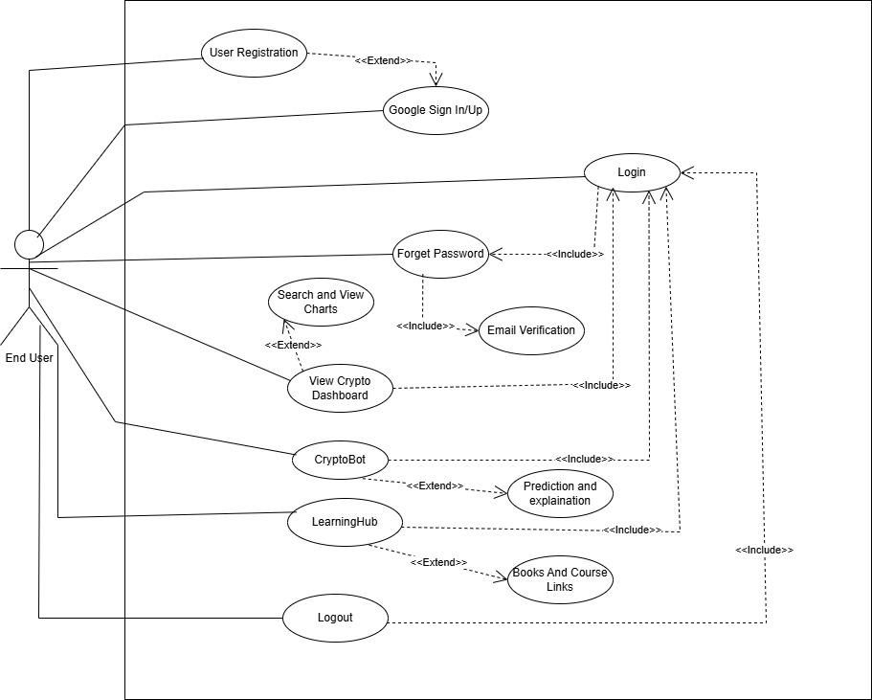

Storyboard
Figure 2 storyboard picture
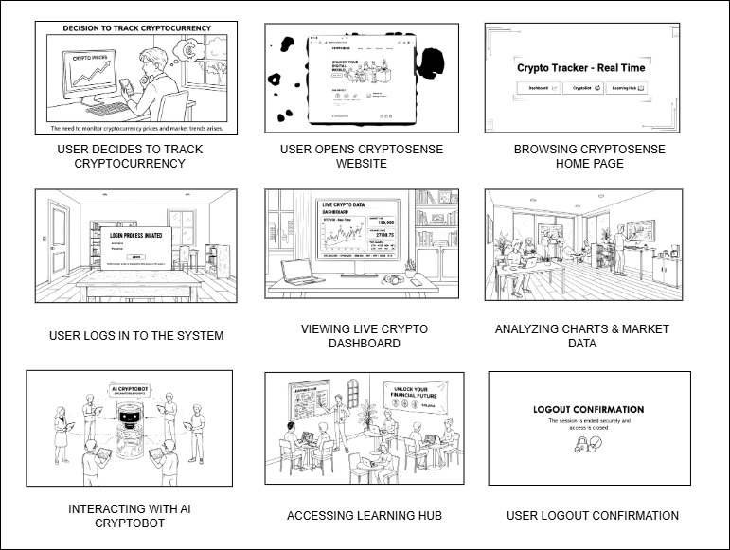

Summary
CryptoSence is a platform that brings login security, live crypto prices, and a Cryptobot help in one platform. It uses Coingecko for real time data and Gemini to chat with users and explain things. This makes it easy for users to learn and understand crypto, and also helps them in trading with a simple and secure system.

Chapter No 4

Software Design Specification

System Design

Product Perspective:
The website name is CryptoSence and it is a client server architecture.
The CryptoSence website provide:
- Live crypto data
- Cryptobot for prediction and explanation
- User login/signup
- Crypto education support
It is made using the MERN stack

Dependencies:
CryptoSence needs the following things to work:
- Coingecko API to get live crypto market data.
- Gemini API to generate prediction.
- React.js to make the website
- Chart.js to show crypto charts
- Node.js + Express for backend
- MongoDB to store user accounts
- Internet connection must required

Design Constraints:
- Performance Requirements: The live crypto data showing and Cryptobot response in a few seconds and work fast
- Usability Requirements: The website is friendly, easy to use and also work on mobile and computer
- Security Requirements: User password and login must be safe and secure. And API keys should be hidden

Design Considerations

Assumptions
Following are the assumptions:
- The system needs a stable internet connection
- User have a phone or computer with a web browser.

Dependencies
Following are the dependencies:
- Coingecko API for live crypto market data.
- Gemini API for generate answers.
- Internet connection.
- React.JS, Node.JS, Express.JS and MongoDB.

Limitations
Following are the limitations:
- Live crypto data uses free Coingecko API which have limited request.
- Cryptobot depend upon volume, RSI, and support/resistance for prediction.
- Both are not work without internet
- Free API may be slow or stop if to many people use it.

Risks
Following are the risks:
- If API of Coingecko and Gemini is fail due to some reason the live crypto data or Cryptobot response is also not work.
- Secondly if the more users call API from Coingecko so we need to buy paid version.

Requirements Traceability Matrix
Table 24 Requirement Traceability Matrix table
Requirement ID | Scope | Requirement Description | Design Specification
FR-1 | User Management | The user shall be able to register by entering username, email and password then account create | Component “user authentication”
FR-2 | User Management | The user should be login by entering email and password then view the dashboard | Component “user authentication”
FR-3 | User Management | The user shall be able to reset their password by email A reset link will be sent to the provided email and allowing the user to create a new password | Component “user authentication”
FR-4 | User Management | The user should be sign in/up by google account | Component “user authentication”
FR-5 | Crypto data Management | The user can access real time price, percentage coin and market data, search bar for searching any currencies and also view crypto currencies charts and other update which you went to know. | Component “coin data service”
FR-6 | AI Support | The user can know about any cryptocurrencies prediction, trends and also few line of explanation about coins | Component  “Cryptobot Page”
FR-7 | Learning Support | The user can also access the best education platform, books and YouTube channel links which will be arranged in sequence of learning | Component “Learning Hub Page for education service”
FR-8 | User Management | The user went to logout from dashboard securely | Component “user authentication”

Design Models
The CryptoSence is a three-tier architecture:
- Presentation Layer (React.js, HTML, CSS)
- Application Layer (Node.js/Express.js)
- Data Layer (MongoDB)
This is object oriented programming approach.

Design Class Diagram
Figure 3 Design Class Diagram
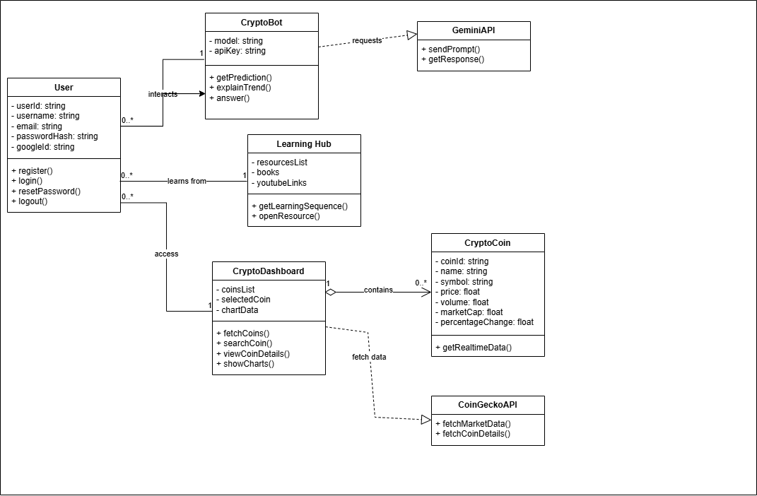

Sequence Diagram
- User Registration Sequence Diagram
Figure 4 User Registration Sequence Diagram
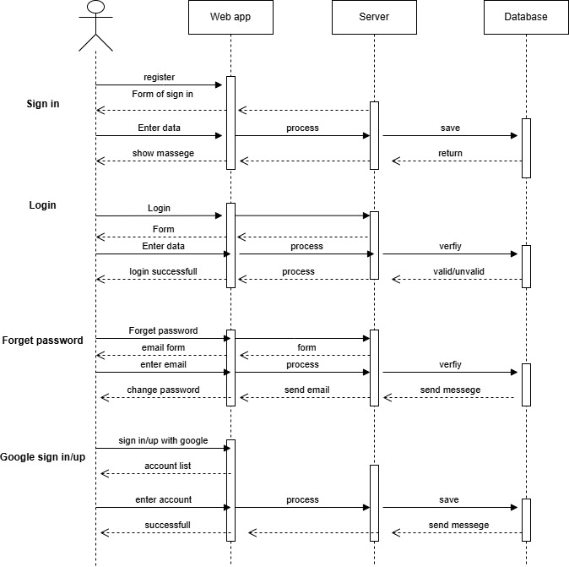
- Home Page Sequence Diagram
Figure 5 Home page Sequence Diagram
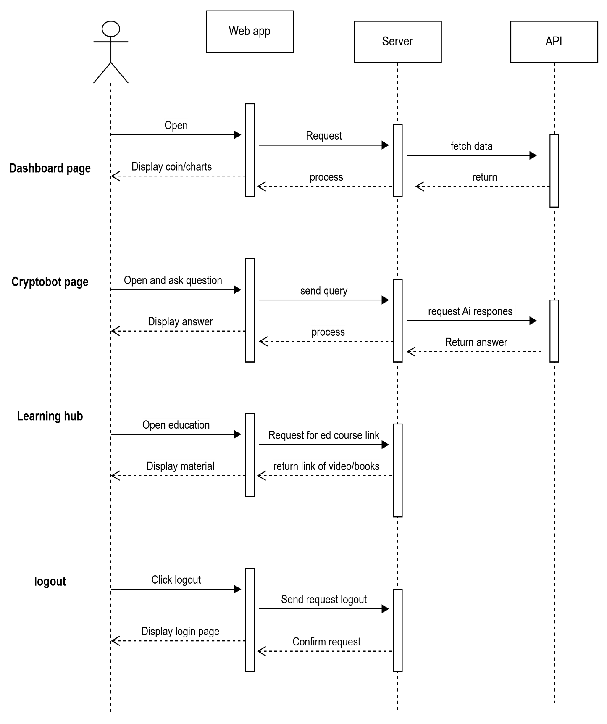

State Diagram
- User Registration State Diagram
Figure 6 User Registration State Diagram
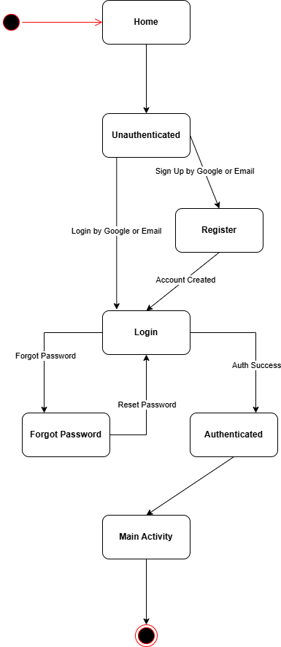

- Dashboard State Diagram
Figure 7 Home Page State Diagram
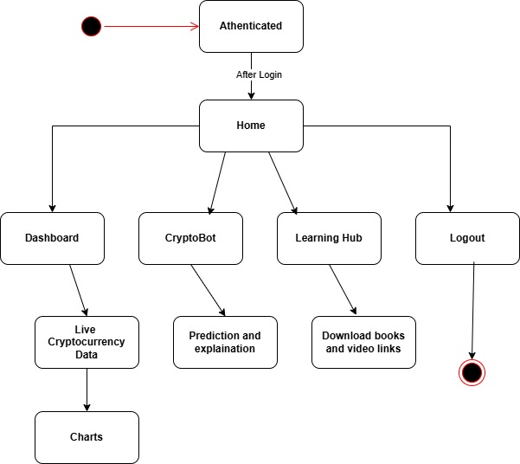

Architectural Design
The system uses a multi-tier design which means the work is divided into different parts. Each part has its own job. This makes the system easier to manage, faster to update, and better at handling changes.

Architectural Diagram
Figure 8 Architectural Diagram
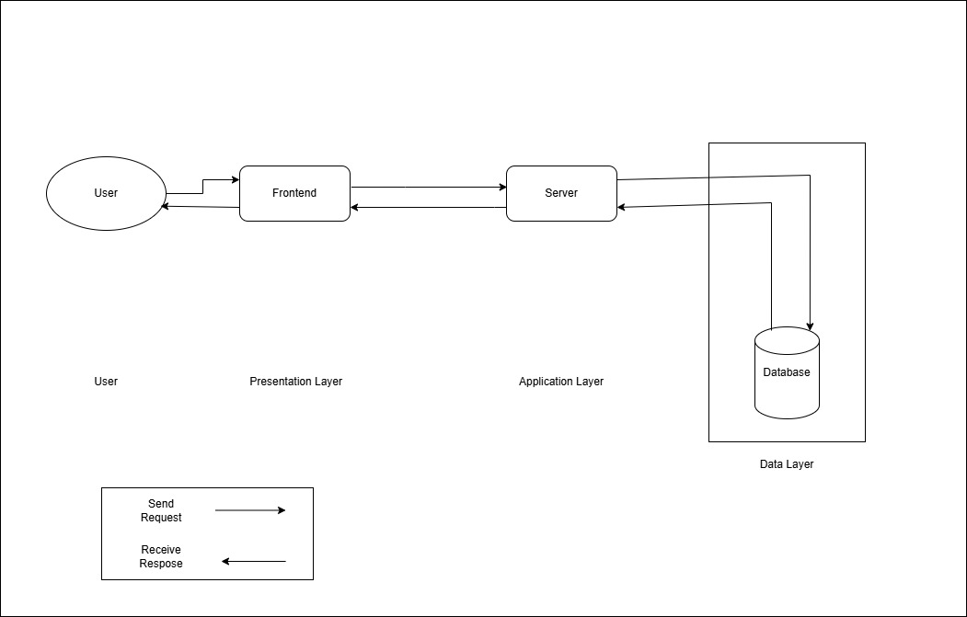

UML Component Diagram
Figure 9 UML Component Diagram
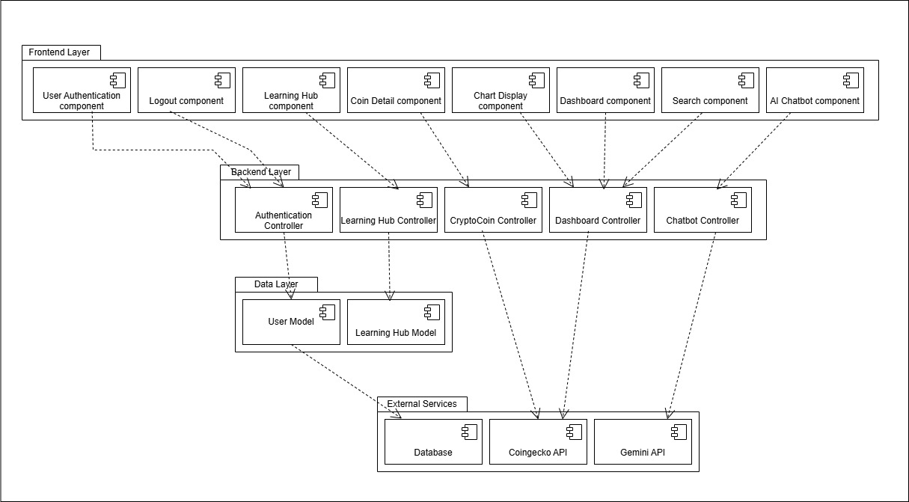

Data Design
The CryptoSence system changes user actions into organized data that is stored in MongoDB. Cryptocurrency prices and charts are not saved in the database because they are fetched live from the Coingecko API. Only user-related information is stored in the system.
The system stores data in different collections in MongoDB to manage it easily.

Database Collections Structure:
Users Collection
- Stores all user accounts.
- Support both normal login and Google login.
- Used for authentication and personalization.
Fields:
- userId: Unique identifier
- username: Full name of the user
- email: User email (unique)
- passwordHash: Encrypted password (empty if Google login is used)
- googleId: Google account ID (optional)
- createdAt: Account creation date
- lastLogin: Last login time
Data Relationships:
- One-to-one: Each user has one account.
- No crypto data stored: All coin details come from Coingecko API.

Data Dictionary
Users Collection:
Table 25 Data Collection table
Terminology | Description
userId | String, Primary key for user
username | String, User full name
email | String, Unique email address
passwordHash | String, Encrypted password
googleId | String, Google login ID (optional)
createdAt | Date, When user registered
lastLogin | Date, Last time user logged in

User Interface Design
The user interface of CryptoSence shows clean and simple data which can easily understand for user. The design helps users quickly find crypto data, use the Cryptobot and Learning Hub.
User Experience
- The system is easy to use and works smoothly on both mobile and computer.
- Users can access live crypto data, charts, and Cryptobot answers in just a few clicks.
- Information is shown in a clean and simple format so users understand it quickly.
- The system loads fast and gives clear messages if something goes wrong.
- The whole experience is friendly, comfortable, and designed to help beginners and experts both.
How the User Uses the System?
1. Open the Website
- User opens the CryptoSence website on mobile or computer.
2. Login or Signup
- If the user is new they create an account.
- If the user already has an account they login with email/password or google.
- Go to Home Page
- After login, the user enters the Home Page.
- The user can see:
  - Navigation Bar with links
  - Quick access buttons to Dashboard, Cryptobot and Learning Hub
- Access Dashboard
- The user can see:
  - live crypto prices
  - percentage change
  - charts
  - search bar
4. Search & View Crypto Details
- The user types a coin name Bitcoin.
- The system shows price, chart, and market details.
5. Use the Cryptobot
- The user goes to the Cryptobot page.
- They ask questions like:
  - Give prediction
  - Explain trends
- The bot replies with simple explanations.
6. Visit the Learning Page
- Users can read educational content and open links to books, videos, and tutorials.
7. Logout
- When the user finishes, they logout safely from the Home Page.

Screen Images

Home Page
Figure 11 Home Page design
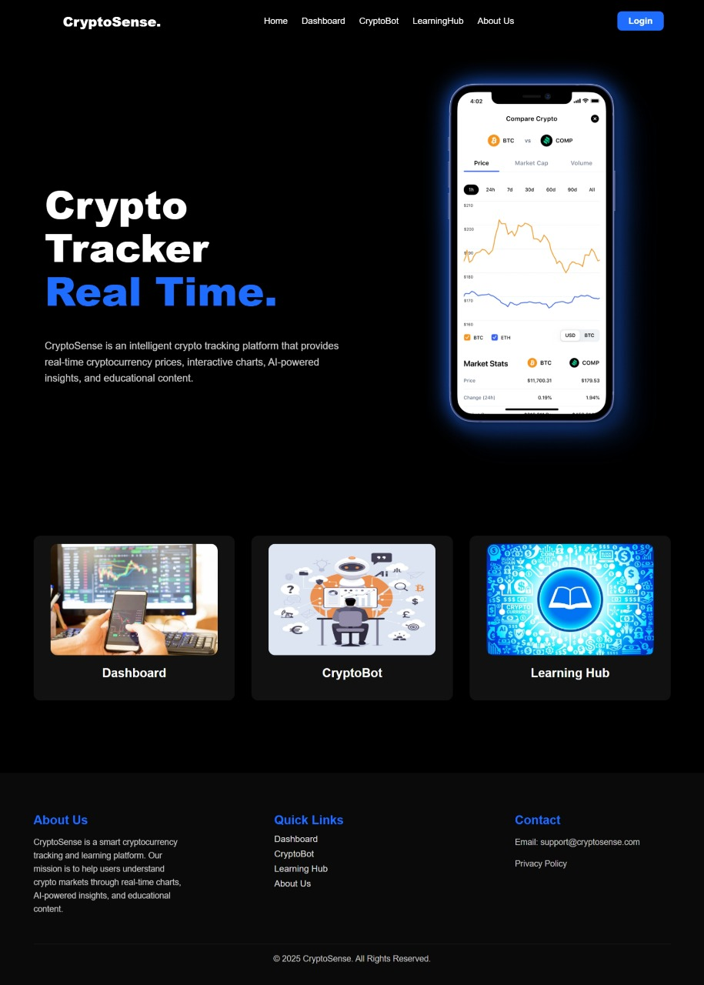

Login Page
Figure 12 Login Page Design
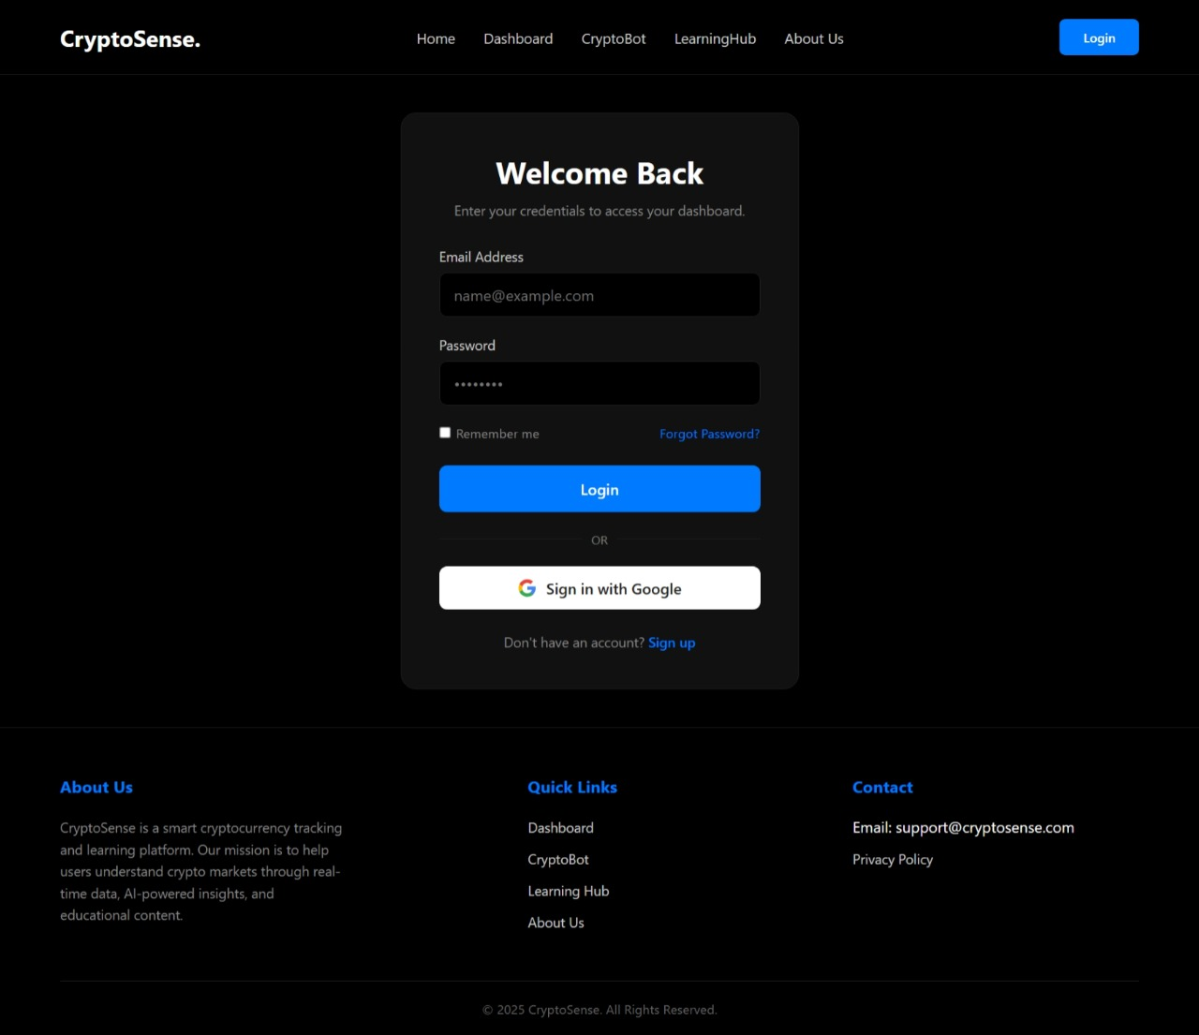

Dashboard Page
Figure 13 Dashboard Page Design
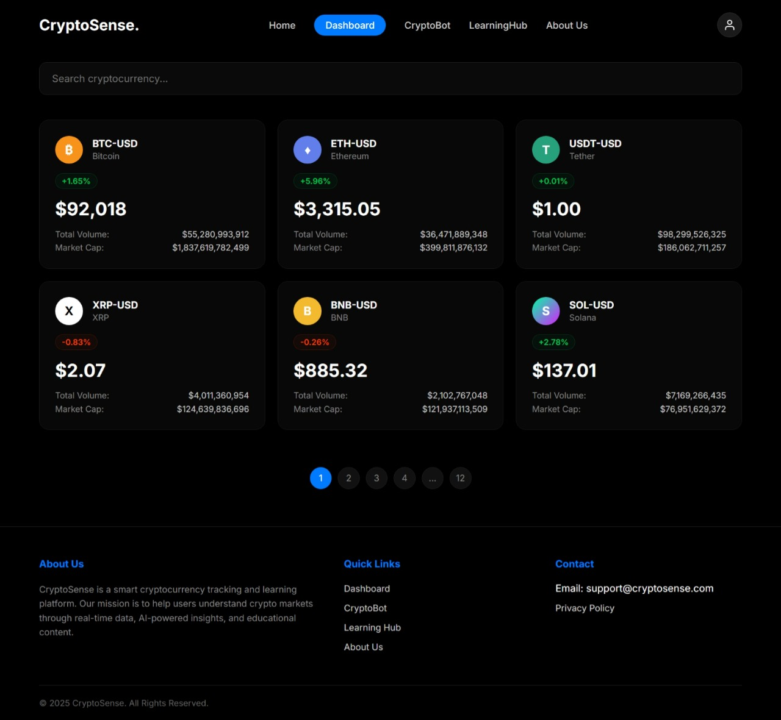

Cryptobot Page
Figure 14 Cryptobot Page Design
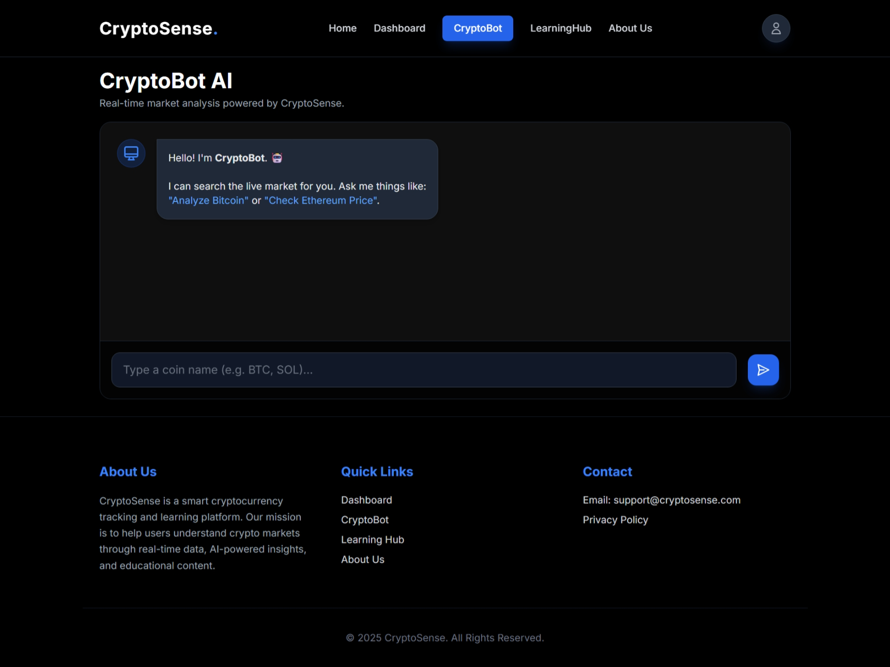

Screen objects and action
Screen Objects
- Nav bar: Home, Dashboard, Cryptobot, Learning Hub, Logout.
- Buttons: Login, Sign in, Google sign in/up, Search, Chat send
- Input Fields: Email, Password, Username, Search bar, Chat
- Boxes: Crypto price, chart, info.
- Charts: Chart for price
- Lists: Crypto list with price and percentage change.
- Icons: Search, profile, menu.
- Messages: Cryptobot messages.
- Footer: Links or credits.

User Actions
- Login / Sign in: User enters details and click login or sign in.
- Search Crypto: User search coins from bar.
- View Details: User clicks on a coin to see price, chart, and market data.
- Cryptobot: User use it for prediction and explanation about any coin.
- Nav bar: User clicks Dashboard, Cryptobot, Learning, etc.
- Logout: User clicks the logout to exit
- Google sign in/up: User signs in/up with google account.

Design Decisions
The system made several key architectural and technological choices to ensure the platform is secure, scalable, maintainable and a high quality user experience.
- Object Oriented Design (OOD):
We used the object oriented approach to build our system around real world entities such as User, Session, Chatmessage, and APIrequest. This code reusability and makes the system easier to use, test, and maintain in the future.
- MVC (Model-View-Controller) Architecture:
The system follows the Model-View-Controller pattern to separate concerns clearly:
  - Model interacts with MongoDB.
  - View is managed by React.js components
  - Controller contains the Express.js routes.
- Database Design with MongoDB:
We chose MongoDB because it is flexible and handles different types of data easily. It works well for user profiles and session data. It stores data in a simple way, so no complex joins are needed. This makes storing and retrieving data faster and easier.
- Rules & Cryptobot Logic:
  - A rule-based layer handle queries to show cryptocurrency data.
  - An AI layer using Gemini API provide prediction and trend explanation which based on technical indicators like volume, RSI, and support/resistance level.
- Technology Stack Selection:
  - Frontend: React.js with Chart.js.
  - Backend: Node.js and Express.js.
  - Database: MongoDB
  - Authentication: JWT (JSON Web Tokens) with bcrypt password hashing ensures secure user session and data protection.
  - External APIs: Coingecko API for real time cryptocurrency data and Gemini API for intelligent responses

Summary
This software design specification outlines the architectural, data, and behavioral designs for CryptoSence. The system shows live crypto data, Cryptobot, and educational content into one secure, fast, and user friendly platform.

References

References

World Wide Web
- Meta Platforms Inc., "React Documentation,". Available: https://react.dev/.
- System Design Specification (SDS) "YouTube lecture used to understand Software / System Design Specification". Available: https://www.youtube.com/watch?v=hOH7eD9NJgY .
- Class Diagram (UML), "YouTube tutorial used to learn UML Class Diagrams". Available: https://www.youtube.com/watch?v=6XrL5jXmTwM .
- Component Diagram, "YouTube tutorial used to understand Component Diagrams". Available: https://youtu.be/CW9Ts2qLfEI?si=QXdUxthCEo-fcigr .
- Sequence Diagram, "YouTube tutorial used to learn Sequence Diagrams using draw.io". Available: https://www.youtube.com/watch?v=rsTWufuP328 .
- OpenJS Foundation, "Node.js Documentation,". Available: https://nodejs.org/en/docs/.
- MongoDB Inc., "MongoDB Manual,". Available: https://www.mongodb.com/docs/manual/.
- The guide for using Mongoose with a database., "Mongoose Documentation," Available: https://mongoosejs.com/docs/.
- Coingecko. “Coingecko API Documentation.”
Internet: https://www.coingecko.com/en/api.
- Gemini. “Gemini API Documentation.” Internet: https://platform.gemini.com/docs.
- Auth0, "Introduction to JSON Web Tokens,". Available: https://jwt.io/introduction.
- Draw.io User Manual for UML Diagrams. Available: https://www.drawio.com/.

